“GET SMART” with iMAPS New England

Exhibit at our 37th Symposium & Expo

May 4, 2010
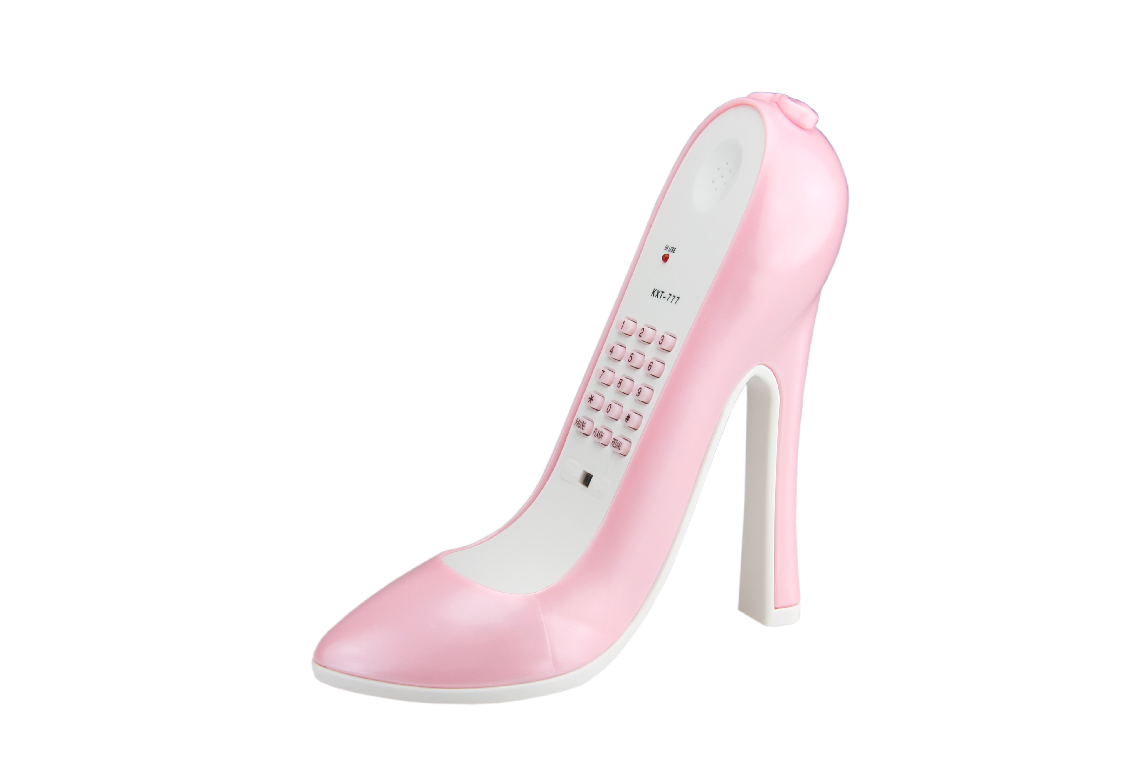

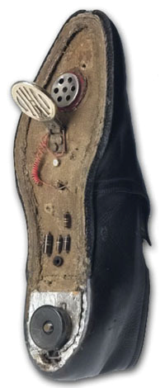
"Get Smart"

"With iMAPS NE"

1970 2010 1990
EXHIBITOR REGISTRATION FORM
Booth rental fee is $585 Until April 10, 2010 and includes:

8' x 10' Carpeted Booth with Table and Chairs
Company Sign & 110V Electrical Service
A Full Symposium Registration
Logo & Link Listed on our Chapter Website
Wireless Internet Access

Hors D'oeuvres in Exhibit Hall
Lunch & Beverage Tickets
Unlimited Exhibits Passes
List of Attendees
Very High Fun Quotient

Don’t Delay…!!! ACT NOW...!!!

Print Clearly
Company Name
Company Sign in Booth [if different]
Your Website URL May we put a link on the chapter website
Exhibits Coordinator
Address

City State Zip

Phone FAX E-Mail

Business or Product[s] Check if Manufacturer’s Rep 

Person registering with booth [One Only]

iMAPS Individual Member Yes  No  [A separate form will be provided later for registering additional personnel]

Address
City State Zip

Phone Fax E-Mail

Number of spaces requested @ $585.00 each Total for Booth Space $
Credit Card Number ______________________________________________ Expiration __________ Security Code
Name on Card Billing Address

City State Zip
Communications, Flyers, Exhibits Passes and Raffle information will be e-mailed to both persons listed above.
Comments or requests:

Completed form with check payable to iMAPS New England or credit card payment must be received by April 10, 2010
Mail to: Harvey Smith, 19 Red Coat Lane, Plainville, MA 02762-2207 or FAX to 508-695-6447
or e-mail completed form to harveys@imapsne.org

For more information E-Mail: harveys@imapsne.org - or - Phone: 508-699-4767 [Harvey Smith or Judi Eicher]

and make frequent visits to our website: www.IMAPSNE.ORG
2010021901

